Ideation Phase

Define the Problem Statements

|  |  |
| --- | --- |
| Date | 19 September 2022 |
| Team ID | PNT2022TMID30774 |
| Project Name | Personal Assistance for Seniors Who Are Self- Reliant |
| Maximum Marks | 2 Marks |

**Customer Problem Statement:**

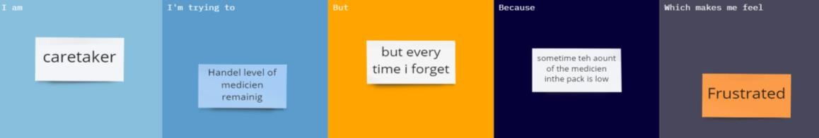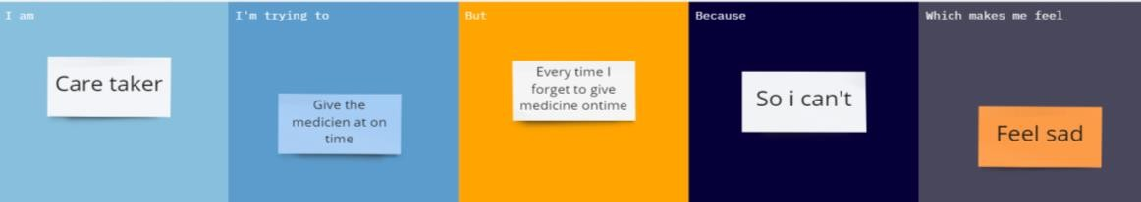

|  |  |  |  |  |  |
| --- | --- | --- | --- | --- | --- |
| **Problem**  **Statement (PS)** | **I am**  **(Customer)** | **I’m trying to** | **But** | **Because** | **Which makes me feel** |
| Can’t Remember the Amount of the medicine  remain | Caretaker | Kept remember the amount of medicine  remain | But I forget every time | Sometime the amount of medicine is less in the  pack | Frustrated |
| Can’t Give medicine at time | Caretaker | Give medicine at time | Every time I miss it | I forget it to give the medicine in sometimes | Feel sad |